CMPE-492

Low Level Design Report

MAI Therapist

Gülden Ünal

Project Supervisor:

Prof.Dr. Tolga Kurtuluş Çapın

Hatice Esra Yılmaz

Renas Barış Özkal

Uğur Kellecioğlu

Contents

1.Introduction 3

1.1 Object Design Tradeoffs 3

1.2 Engineering Standards 3

1.3 Definitions, acronyms, and abbreviations 4

2. Packages 4

2.1 Server Package 4

2.1.1 Authentication Package 4

2.1.2 Data Storage Package 4

2.1.3 Request Handling Package 5

2.2 MAI Therapist Analysis Package 6

2.2.1 Analysis Package 6

2.2.2 Results Package 6

3. Class Interfaces 7

4. Glossary 9

5. References 10

# 1.Introduction

Effective therapy has been a complex process that needs a deep understanding of the client's emotions and actions. It is the therapist's job to evaluate and understand these emotions correctly to help their clients overcome their issues. However this is not an easy task as you may guess. Usually therapists need to improve their ability to read emotions and understand their clients better to provide successful therapy sessions.

Therapists needs time, trial and error and lots of practice to improve their skills. They need to hone their abilities to recognize and respond to clients' cues effectively. This skill comes with time, practice, and reflection as we stated before. However, even the most experienced therapists may overlook significant points during sessions, leading to self-doubt and stress about their approach.

That’s why we release a helpful ai - MAI Therapist. MAI Therapist is an innovative technology designed to help therapists improve their skills and provide better therapy to their clients. It analyzes emotions, gestures, and facial expressions to provide a better understanding of their clients. With this technology therapists can read their clients' emotions more accurately and interpret them correctly and leading to better therapy outcomes.

Furthermore, MAI Therapist allows therapists to get an analysis of each session. This analysis can be used to identify the strengths and weaknesses of the therapist's approach and adjust accordingly. This feature enables continuous improvement, resulting in better therapy outcomes for clients.

In addition to improving therapists' abilities, MAI Therapist reduces stress by providing an opinion on missed points during sessions. It provides a reliable tool for therapists to correct their approach, ensuring their clients receive the best care possible.

In conclusion, therapy is an essential process that requires therapists to be able to read their clients' emotions and interpret them correctly. MAI Therapist is a powerful tool that helps therapists improve their skills and provide better therapy to their clients. With its innovative technology and analytical features, therapists can continuously improve their approach and provide better care to their clients.

# 1.1 Object Design Tradeoffs

Accuracy vs. speed:

Finding the right balance between accuracy and speed is important in terms of the app’s effectiveness. The precision in our application is very important. A more accurate script and analysis of the session may take longer to provide. In order to achieve this accuracy, we decided not to seek a super-fast response and focus on the accuracy instead.

Personalization vs. Privacy:

MAITheraphist can be designed to be highly personalized, but this requires collection of lots of personalized information about user, which can raise privacy concerns. Since the privacy of a therapist’s clients are substantial, our target audience will be look for something that they can trust. So, we offer a private application with sacrificing the personalization design.

Data Availability vs. Data Quality:

There is a trade-off between data availability and data quality. Using low quality data can cause inaccurate responses, while using high-quality data can be more time consuming and more expensive. But like we mentioned in the accuracy vs. speed tradeoff, we want accuracy. So we will be using high-quality data in order to achieve the accuracy we seek.

Simplicity vs. Complexity:

A more complex app may be able to offer more advanced features but may be more difficult for users to navigate and understand. Thinking about our users, we choose simplicity over complexity for making an easy to use app.

1.2 Interface Documentation Guidelines

Class: Name of the class

Description: Explanation of the class

Package: Which module is class belong

Operations: Set of methods that class have

# 1.2 Engineering Standards

MAITherapist cares about privacy, ethical standards, usability and accuracy. By adhering engineering standards which are:

Privacy & Security Standards,

Ethical Standards,

Usability Standards,

Quality Assurance Standards

Us, MAITherapist developers, can help ensure that our product is safe, effective, reliable and accessible to a wide range of users.

# 1.3 Definitions, acronyms, and abbreviations

Session: A period of time that is spent during the therapy.

Client: A client refers to the device or web browser that is used to access and interact with the application over the internet that is used by the users.

Therapist (psychotherapist): A specialist who treats a particular type of illness or problem, or who uses a particular type of treatment.

Analysis: The detailed study or examination of something in order to understand more about it; the result of the study

Script: written text of what is spoken; written characters.

# 2. Packages

The system will be organized into packages to help manage complexity and facilitate modular development. Each package will contain a set of related components and will provide a well-defined interface for interacting with those components.

# 2.1 Server Package

The Server package will contain the components responsible for hosting and managing the therapy system, including user authentication and authorization, data storage and backup, and request handling. This package will have the following sub-packages:

# 2.1.1 Authentication Package

The Authentication package will contain components responsible for managing user authentication and authorization. This package will have the following sub-packages:

* Login: This sub-package will handle user login functionality, including user verification and session management.
* Authorization: This sub-package will handle user authorization functionality, including access control and permission management.

# 2.1.2 Data Storage Package

The Data Storage package will contain components responsible for managing the data storage and backup of the system. This package will have the following sub-packages:

* Amazon S3: This sub-package will handle the storage and retrieval of therapy sessions and analysis results using Amazon S3 service.
* Amazon RDS: This sub-package will handle the management of therapy session and analysis results data using Amazon RDS service.

# 2.1.3 Request Handling Package

The Request Handling package will contain components responsible for handling requests from the Client subsystem and directing them to the appropriate module for processing. This package will have the following sub-packages:

* Routing: This sub-package will handle the routing of requests to the appropriate module for processing.
* Error Handling: This sub-package will handle the error and exception handling functionality, ensuring that errors are properly logged and communicated to the client.

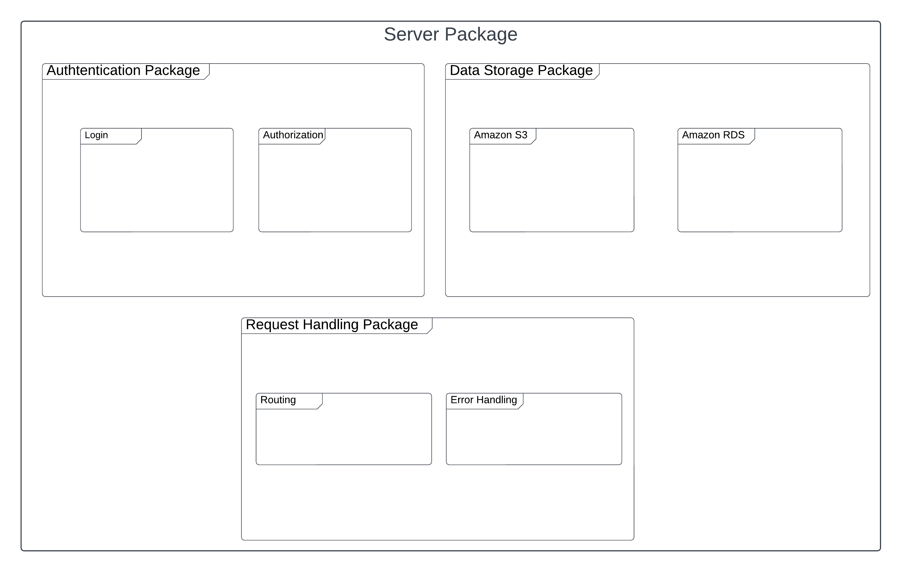

# 2.2 MAI Therapist Analysis Package

The MAI Therapist Analysis package will contain the components responsible for performing the analysis of the therapy sessions. This package will have the following sub-packages:

# 2.2.1 Analysis Package

The Analysis package will contain the components responsible for performing the actual analysis of the therapy sessions. This package will have the following sub-packages:

* Preprocessing: This sub-package will handle the preprocessing of the therapy session data, including cleaning and normalization.
* Feature Extraction: This sub-package will handle the feature extraction from the preprocessed data.
* Model Training: This sub-package will handle the training of the analysis model.
* Model Evaluation: This sub-package will handle the evaluation of the analysis model.

# 2.2.2 Results Package

The Results package will contain the components responsible for managing the results of the analysis. This package will have the following sub-packages:

* Storage: This sub-package will handle the storage of the analysis results in the server data storage system.
* 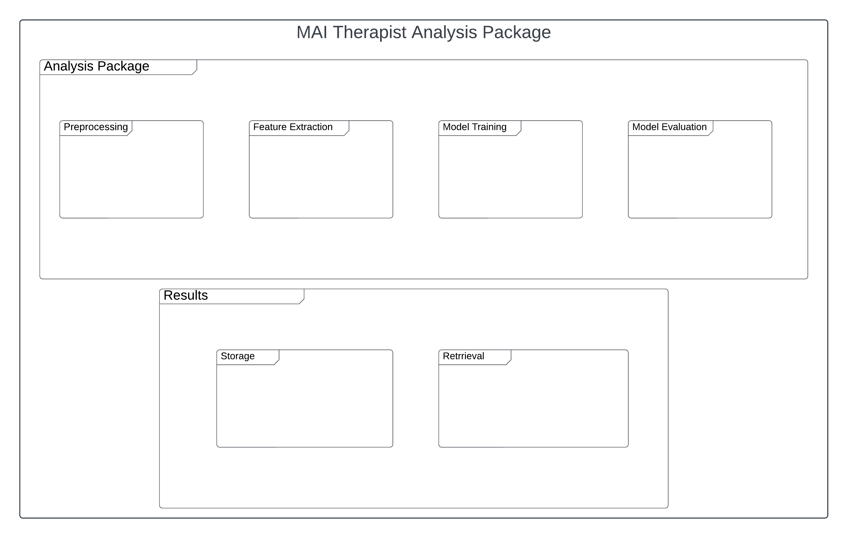Retrieval: This sub-package will handle the retrieval of the analysis results for presentation to the client.

# 3. Class Interfaces

|  |  |
| --- | --- |
| CLASS | AuthStore |
| Description | This class handles authentication, authorization of the user across the app |
| Package | Authentication |
| Attributes | User {  First Name  Last Name  Email  Token  Patient []  Analyze []  } |
| Operations | isSignedIn(): Boolean  getUser(): User  resendConfirmationCode(email:string): void  confirmSignUp(email: string, confirmCode: string): void  signUp(user: User): void  signIn(user: User): void  signOut():void |

|  |  |
| --- | --- |
| CLASS | VideoUpload |
| Description | This class uploads the session video to aws system |
| Package | TherapyAnalysis |
| Attributes | Client:Patient  Video:Video  User:Therapist |
| Operations | sendVideo():void  sends the session video to amazon web services system to analyse or getting transcript of the session  getClient():Patient  with two way data bindings, and connection to our serverless system, we get client and connect it to video properties to send the data.  getTherapist():User  with two way data bindings, and connection to our serverless system, we get user(therapist) and connect it to video properties to send the data. |

|  |  |
| --- | --- |
| CLASS | GetTranscript |
| Description | This class manages the getting and sending the transcript system of client |
| Package | TherapyAnalysis |
| Attributes | Client:Patient  Video:Video  User:Therapist  Transcript:Transcript |
| Operations | getTranscript():Transcript  this method gets the transcrypted version of the session belongs to the client where the therapist needs it.  convertTranscrypt():Patient  It converts the video (speech to text) with a feature of aws on the aws console and creates a transcript of the session. |

|  |  |
| --- | --- |
| CLASS | CreateNewClient |
| Description | This class provides our users to add a new client to their client list. |
| Package | DashboardMainComponents |
| Attributes | Name: String  Surname: String  Id: String  Age: String  Gender: String  Diagnosis: String |
| Operations | createPatient(): Patient  This method creates new client for the user’s client list, and adds the given informations to it. |

|  |  |
| --- | --- |
| CLASS | patientApi |
| Description | This class gets all clients’ data and a specific client’s data from the aws |
| Package | RequestHandlingPackage |
| Attributes | allPatients: Object  selectedPatient: Object |
| Operations | getAllPatients(): Array  Gets all patients from the aws by using useAxios class.  getPatient(id): Object  Gets spesific patient from the aws by using useAxios class, by providing the id parameter. |

|  |  |
| --- | --- |
| CLASS | AllClients |
| Description | This class gets all clients’ records from the patientApi class and provides therapists to see them. |
| Package | RequestHandlingPackage |
| Attributes | allClients: Array  selectedPatientId: String |
| Operations | getAllPatients(): Array  Gets all patients’ data from the patientApi class.  getPatientDetails(patientId, patient): void  This method sets selected patient in the patientApi class by giving patient object in the parameter. Then sets path including patientId to the router to show the patient details. |

|  |  |
| --- | --- |
| CLASS | Register |
| Description | This class creats a new account |
| Package | RegisterPageComponents |
| Attributes | email: String  password: String  confirmCode: String  creditCardNumber: String  ccExpDate: String  ccSecCode: String |
| Operations | submitForm(): sending the form to backend. A confirmation code will be sent to the given email  resendConfirmationCode(): request for receiving the confirmation code once again.  confirmSignUp(): if the code is approved, registration process will be confirmed |

|  |  |
| --- | --- |
| CLASS | Login |
| Description | This class provides our users to login to their accounts |
| Package | LoginPageComponents |
| Attributes | email: String  password: String |
| Operations | submitForm(): sending the form to backend. If the informations are true, login will be successful. |

# 4. Glossary

Amazon S3: Amazon S3 or Amazon Simple Storage Service is a service offered by Amazon Web Services (AWS) that provides object storage through a web service interface.

Amazon RDS: Amazon Relational Database Service (or Amazon RDS) is a distributed relational database service by Amazon Web Services (AWS).[2] It is a web service running "in the cloud" designed to simplify the setup, operation, and scaling of a relational database for use in applications.

Server: A software program or a computer that provides services to other software programs or other computers.

Authentication: Authentication is the process of determining whether someone or something is, in fact, who or what it says it is. Authentication technology provides access control for systems by checking to see if a user's credentials match the credentials in a database of authorized users or in a data authentication server

Routing: The process of selecting a path for traffic in a network or between or across multiple networks. Broadly, routing is performed in many types of networks, including circuit-switched networks, such as the public switched telephone network (PSTN), and computer networks, such as the Internet.

# 5. References

1. American Psychiatric Association. (2013). Diagnostic and statistical manual of mental disorders (5th ed.).
2. Bostock, S., Cross, S., & Jones, M. (2016). Virtual reality and serious games in mental health treatment. The British Journal of Psychiatry, 209(2), 85-87.
3. Cuijpers, P., Donker, T., Johansson, R., Mohr, D. C., van Straten, A., & Andersson, G. (2011). Self-guided psychological treatment for depressive symptoms: A meta-analysis. PLoS ONE, 6(6), e21274.
4. IBM. (2021). IBM Watson. Retrieved from <https://www.ibm.com/watson>
5. Kuhn, E., Kanuri, N., Hoffman, J. E., Garvert, D. W., Ruzek, J. I., & Taylor, C. B. (2017). A randomized controlled trial of a smartphone app for posttraumatic stress disorder symptoms. Journal of Consulting and Clinical Psychology, 85(3), 267-273.
6. National Institute of Mental Health. (2019). Technology and the future of mental health treatment. Retrieved from <https://www.nimh.nih.gov/health/topics/technology-and-the-future-of-mental-health-treatment/>
7. OpenAI. (2021). OpenAI. Retrieved from <https://openai.com/>
8. Oulasvirta, A., Rattenbury, T., Ma, L., & Raita, E. (2012). Habits make smartphone use more pervasive. Personal and Ubiquitous Computing, 16(1), 105-114.
9. Riva, G., Gamberini, L., Wiederhold, B. K., & Cipresso, P. (2016). Positive technology and mental health: From apps to rehab. Cyberpsychology, Behavior, and Social Networking, 19(3), 177-179.
10. Rosen, R., & Thompson, D. (2016). E-mental health: The future of youth mental health? International Journal of Mental Health Promotion, 18(4), 198-208.
11. Schueller, S. M., & Leykin, Y. (2018). Digital mental health and stigma: Ready for the challenge? Current Psychiatry Reports, 20(6), 44.
12. Seligman, M. E. P., Steen, T. A., Park, N., & Peterson, C. (2005). Positive psychology progress: Empirical validation of interventions. American Psychologist, 60(5), 410-421.
13. The World Bank. (2018). World Bank country and lending groups. Retrieved from <https://datahelpdesk.worldbank.org/knowledgebase/articles/906519-world-bank-country-and-lending-groups>
14. Torous, J., Roberts, L. W., & Needed, C. (2017). Smartphones, mobile apps, and psychology. Current Opinion in Psychology, 9, 6-9.
15. World Health Organization. (2021). Mental health. Retrieved from <https://www.who.int/mental_health/en/>